Course _______Specialist_____ Year ___12_____

Student name: ________________ Teacher name: ________________

Task type: Response

Time allowed for this task: ____40_______ mins

Number of questions: _____7______

Materials required: Calculator with CAS capability (to be provided by the student)

Standard items: Pens (blue/black preferred), pencils (including coloured), sharpener, correction fluid/tape, eraser, ruler, highlighters

Special items: Drawing instruments, templates, notes on one unfolded sheet of
A4 paper, and up to three calculators approved for use in the WACE examinations

Marks available: ___38___ marks

Task weighting: _10___%

Formula sheet provided: Yes

Note: All part questions worth more than 2 marks require working to obtain full marks.

Q1 (2, 2 & 3 = 7 marks) (3.1.1 to 3.1.3)
If & determine the following.

Q2 (3 marks) (3.1.2)
Determine all possible pairs of real numbers such that

Q3 (2 & 3 = 5 marks) (3.1.13- 3.1.15)
Consider the function .
- Determine the remainder of when divided by .

- Show that is a factor of and hence determine all linear factors.

Q4 (3 marks) (3.1.9)
Determine the complex number in the form with & .

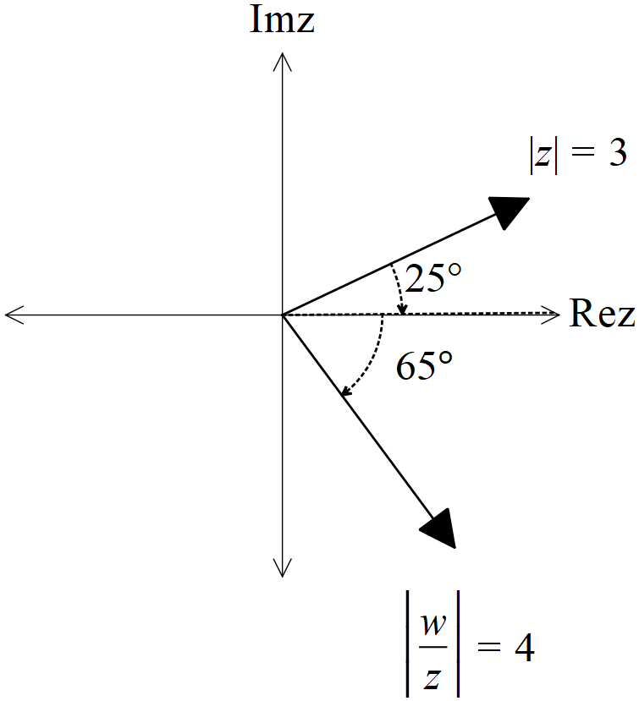

Q5 (2, 2, 3 & 3 = 10 marks) (3.1.10)
Consider the following set of complex numbers such that .
Determine the following.
- Minimum value of . (exact)

- Maximum value of . (exact)

- Maximum value of Arg in radians to two decimal places.

- Maximum value of (exact)

Q6 (3 & 3 = 6 marks) (3.1.6)
Let be complex numbers such that

- Determine the exact value of Arg() in principal form (i.e )

- Determine the exact value of

Q7 (4 marks) (3.1.10)

Sketch the locus of complex numbers that satisfy both of the following
AND in the Argand diagram below.

